**Identity Dimensions for a Core Identity**

**Privileges**

In Identity Dimension, there are three types of categories:

**Owners** = Owners of a Core Identity

**Controllers** = Controllers of a Core Identity

**Delegates** = People delegated access/tokens to an identity

(Recall if someone is an Owner of a Core Identity, they are by default a Controller.)

Below are the privileges of Owners, Controllers and Delegates with respect to dimensions for a Core Identity:

|  |  |  |  |  |  |  |
| --- | --- | --- | --- | --- | --- | --- |
| Has Permission? | **Instantiate Dimension Contract** | **Add,**  **Update**  **Entries** | **Delegate Tokens** | **Delete an Entry** | **Read Entry** | **Kill Dimension Contract** |
| **Owner** | YES | YES | YES | YES | YES | YES – Requires Consensus of all Owners |
| **Controller** | NO | YES | NO | NO | YES | NO |
| **Delegate** | NO | NO | NO | NO | REQUIRES TOKENS | NO |

**Contract Structure**

All interactions for an Identity Dimension happen through the **Identity Dimension Control Contract**. This contract makes use of two helper contracts:

1. **Identity Dimension** – This contract is instantiated for every identity dimension.
2. **Identity Dimension Control Token** – This contract holds information about delegations. Since only Owners can delegate tokens, this contract only needs to stay in sync. with Core Identity Owners.

In addition, **Identity Dimension Control** needs the Core Identity Address of a contract. This allows it to stay in sync with Core Identity Owners.  
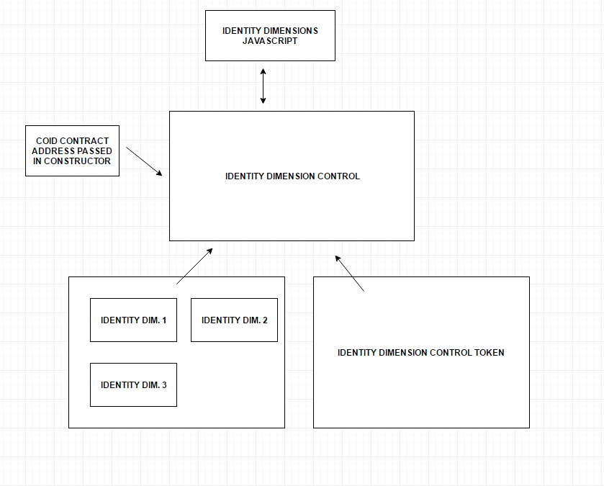

The table below describes the external functions (permissioned through IdentityDimensionControl) in the Identity Dimension contract:

|  |  |  |
| --- | --- | --- |
| **FUNCTION** | **DETAILS** | **TO BE CALLED IN** |
| IdentityDimension  INPUT:  bytes32 uniqueID  string theDimensionType  uint flag | This is the constructor. It adds the first entry (“Owner”, sha3(uniqueID)) public/private based on the flag (0 = public, 1 = private) | The instantiation of an IdentityDimesnion through  IdentityDimensionControl. |
| addEntry  INPUT:  string descriptor  string attribute  uint flag | Returns a boolean value. | Accessible through IdentityDimensionControl. |
| removeEntry  INPUT:  string descriptor | Returns a boolean value. | Accessible through IdentityDimensionControl. |
| readEntry  INPUT:  string descriptor | Returns (string value, bool success, bool isPublic) | Accessible through IdentityDimensionControl. |
| changeDescriptor  INPUT:  string oldDescriptor  string newDescriptor | Returns a boolean value. | Accessible through IdentityDimensionControl. |
| update  INPUT:  string descriptor  string attribute  uint flag | Returns a boolean value. | Accessible through IdentityDimensionControl. |
| isPublic  INPUT:  string descriptor | Returns a Boolean value. | Accessible through IdentityDimensionControl. |
| isPrivate  INPUT:  string descriptor | Returns a Boolean value. | Accessible through IdentityDimensionControl. |
| getPublicDescriptors() | Returns a string of the public descriptors with delimiter “,”. | Accessible through IdentityDimensionControl. |
| getPrivateDescriptors() | Returns a string of the private descriptors with delimiter “,”. | Accessible through IdentityDimensionControl. |